6th Day of Christmas~ Peppermint Brownie Trifle!
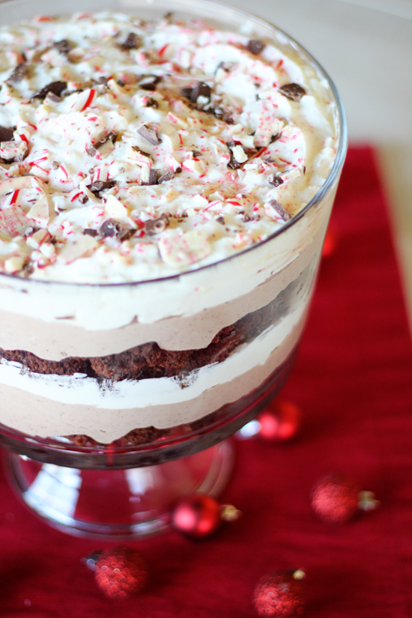
Peppermint Brownies Layered Between White Chocolate and Mint Chocolate Pudding… A Peppermint Brownie Trifle!

Ingredients:
- 1 box brownie mix (I used Sugar Free Pillsbury brand)
- 1/3 cup Low Fat Plain Yogurt, (I used Plain Chobani Greek Yogurt to replace the oil that the brownie mix calls for. Note: The amount of yogurt will vary based on how much oil is called for on the brownie box)
- 1 egg (may vary based on brand of brownies, use what is called for on the box)
- 1 small box sugar free instant white chocolate pudding mix
- 1 small box sugar free instant chocolate pudding mix
- 1 (16 oz) tub fat free or light Cool Whip (or 2 small containers of TruWhip if you prefer a natural version)
- 2 cups skim milk (or milk alternative)
- 3/4 tsp peppermint extract
- Optional toppings: Additional Cool Whip for topping, 2 candy canes, crushed , or 2 squares peppermint bark, roughly chopped.

Method:
- Prepare the brownies according to the package directions, replacing the oil with yogurt, and adding 1/2 tsp peppermint extract to the brownie batter. Bake brownies according to the package directions
- Meanwhile, in a small bowl, mix together the white chocolate pudding mix and 1 cup of milk. In a separate bowl, mix together the chocolate pudding mix, 1 cup of milk, and 1/4 tsp peppermint extract. Next, divide the Cool Whip between the two pudding mixtures, and fold it in until each mixture is combined.
- Once brownies are completely cooled, cut into very small squares, and begin creating the layers in a large glass dish, or in small glass cups for individual trifles. Start with the brownie layer, (I like to space brownies out a bit, so you will have an equal amount for both layers). Follow with the chocolate peppermint pudding, and the white chocolate pudding layers. Repeat layers, ending with the white chocolate pudding, (or top with some additional plain Cool Whip for a pretty presentation).
- Store in the fridge until read to serve. Just before serving, top with crushed candy cane or peppermint bark if desired.
Servings: 16
Calories: 125 calories per serving
Weight Watchers Points Plus Value: 4 per serving

